AXE I- Identitées and exchanges
A. Come together
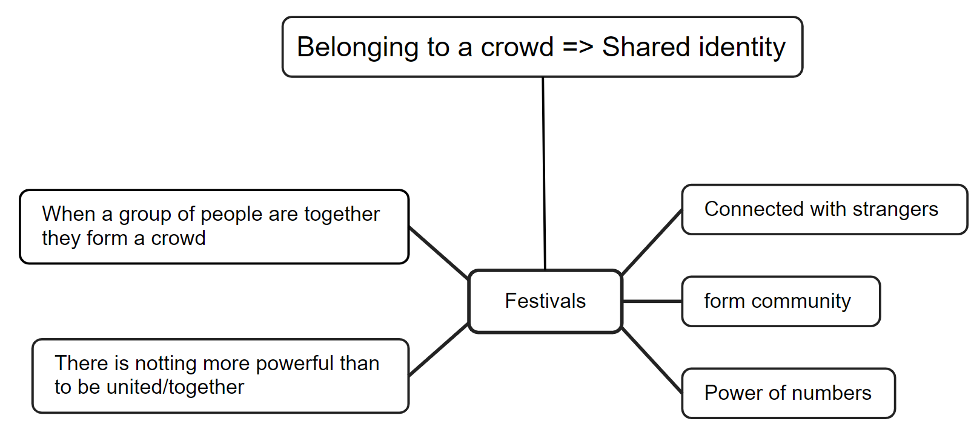

Question : Read the texte
Were you right? What links are made between “crowds”, “power” and events such as Woodstock & Coachella?

Basically, a crowd makes noise, there are lots of people, it's impressive and it can even be scary. What's more, even if it's just a large group of strangers, everyone is connected by an idea, a will, a goal or a conviction.

